Lab 2 – Part 1 : Kaggle
🔹 Dataset Overview
The Netflix dataset contains 8,807 records and 12 attributes, including title, type, country, release year, rating, and duration. The dataset consists of both Movies and TV Shows released across multiple countries and years.
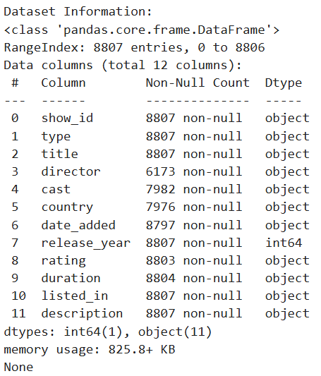

🔹 Data Quality Observation
- Some columns contain missing values, mainly:
  - director (2634 missing)
  - cast (825 missing)
  - country (831 missing)
- These missing values indicate incomplete metadata for some titles but do not prevent basic exploratory analysis.
- No missing values were found in critical fields such as type, title, and release_year.
Inference:
The dataset is suitable for exploratory analysis even though some descriptive fields are incomplete.
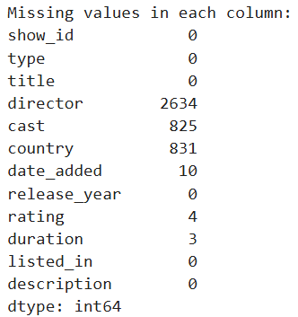

🔹 Content Type Distribution (Movies vs TV Shows)
- Movies: 6,131
- TV Shows: 2,676
Inference:
Netflix’s content library is movie-dominant, with movies making up nearly 70% of the total content. This suggests Netflix focuses more on movie acquisitions and releases compared to TV shows.
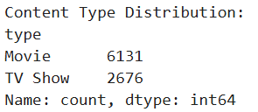
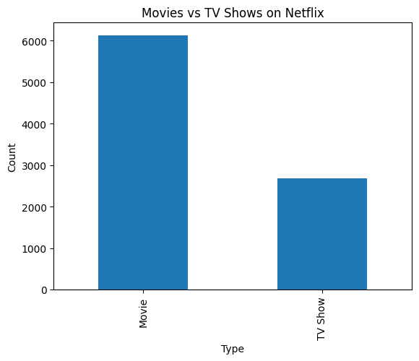

🔹 Country-Wise Content Distribution
Top 10 Content Producing Countries:
- United States – 2,818 titles
- India – 972 titles
- United Kingdom – 419 titles
- Japan – 245 titles
- South Korea – 199 titles
- Canada – 181 titles
- Spain – 145 titles
- France – 124 titles
- Mexico – 110 titles
- Egypt – 106 titles
Inference:
- The United States is the largest contributor to Netflix content.
- India ranks second, showing strong growth in regional and international content.
- Asian countries like Japan, South Korea, and India indicate Netflix’s increasing focus on non-English and regional content.
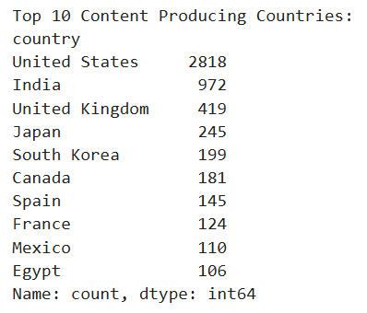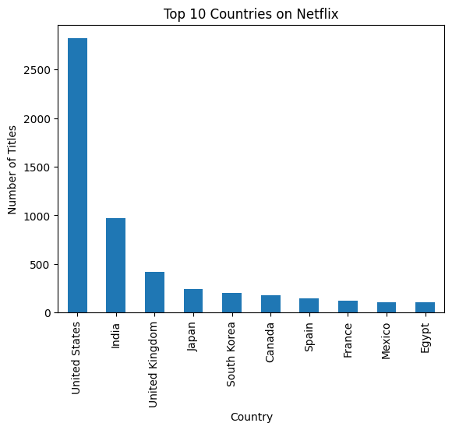
🔹 Rating Distribution Analysis
Most common ratings observed:
- TV-MA: 3,207 titles
- TV-14: 2,160 titles
- TV-PG: 863 titles
- R: 799 titles
Inference:
- A majority of Netflix content is targeted towards mature and teenage audiences.
- The dominance of TV-MA and TV-14 ratings indicates Netflix prioritizes content suitable for older viewers.
- Very few titles fall under children-only ratings, showing a content strategy focused on teens and adults.
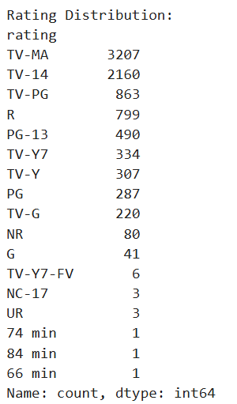

🔹 Overall Conclusion
- Netflix hosts a large and diverse content library with a strong emphasis on movies.
- The platform is globally inclusive, with content sourced from multiple countries.
- Most content is designed for teenage and adult audiences.
- Despite minor missing metadata, the dataset provides valuable insights into Netflix’s content strategy.

🔹 Result Statement (For Lab Record)
The analysis successfully explored the Netflix dataset obtained from Kaggle. Key insights regarding content distribution, country-wise production, and rating patterns were identified using Python and Pandas, fulfilling the objective of simple data analysis.

